# Lab 1. Introduction to modelling

**Name: Zhu Chenhao**

**ITMO ID: 375462**

## Specialization: Automation

## Objective

Familiarize yourself with the Simulink software environment and basic methods for modeling linear electrical circuits.

## Theoretical information

A mathematical model of a linear electric circuit as a linear stationary system can be represented in the form of a scalar differential equation of the *nth* order (input-output model) or in the form of a system of *n* differential equations of the 1st order (input-state-output model).

The input-output model has the form

, (1)

where *y* is the output variable, *u* is the input signal, *n* is the order of the system, *m* is the order of the derivative of the output variable, which explicitly depends on *u*   
( ), *a j* , *b j* are constant coefficients.

Provided that , the input-state-output model can be represented as

 (2)

where *x j* are the coordinates of the state vector, α *ij* and β *j* are constant coefficients. System (2) can be represented in a compact vector-matrix form

**1. Build a simulation circuit.**

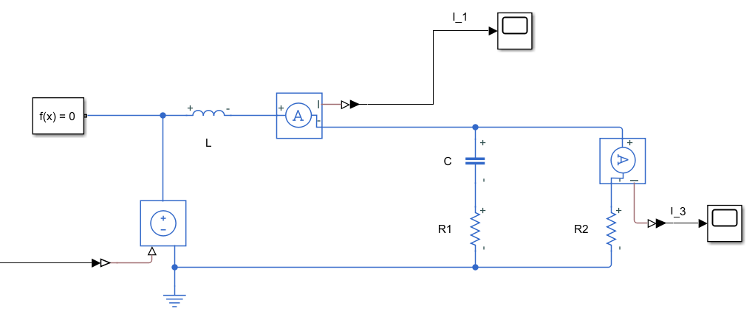

**Figure 1.** Equivalent circuit.

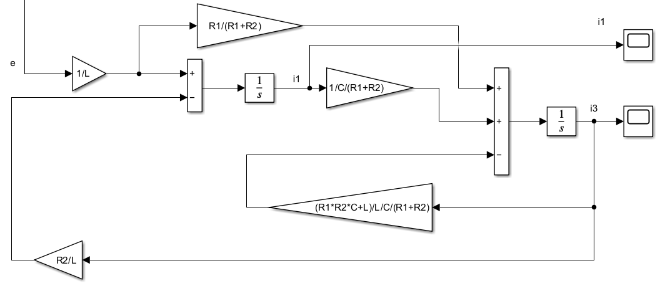

**Figure 2.** Simulation circuit.

**2. Component equations.**



**3. Topological equations.**



**4. State-space model.**

State space form :

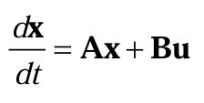



Organizing from Component equations and Topological equations:



I get A and B: 

**5. Simulink simulation of the circuit and the state-space model using the predetermined input and zero initial conditions.**

**Group 1**

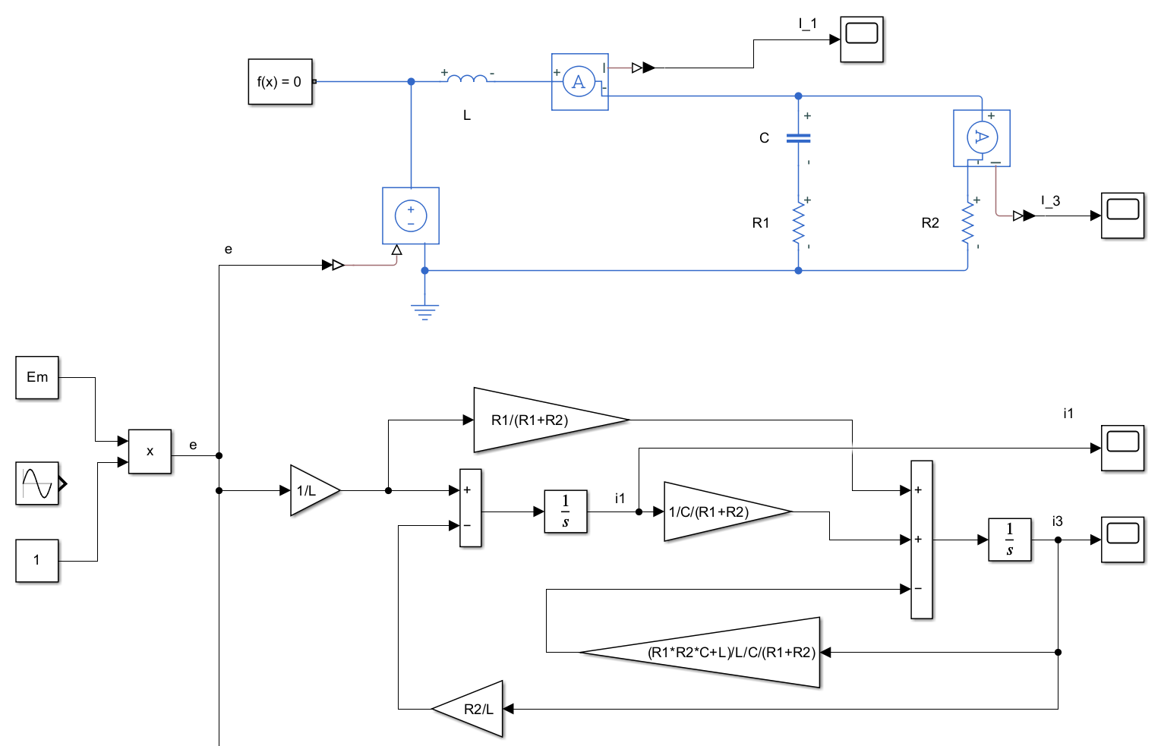

**Figure 3-1.** *simulation with* ***zero initial*** *conditions and* ***constant voltage***

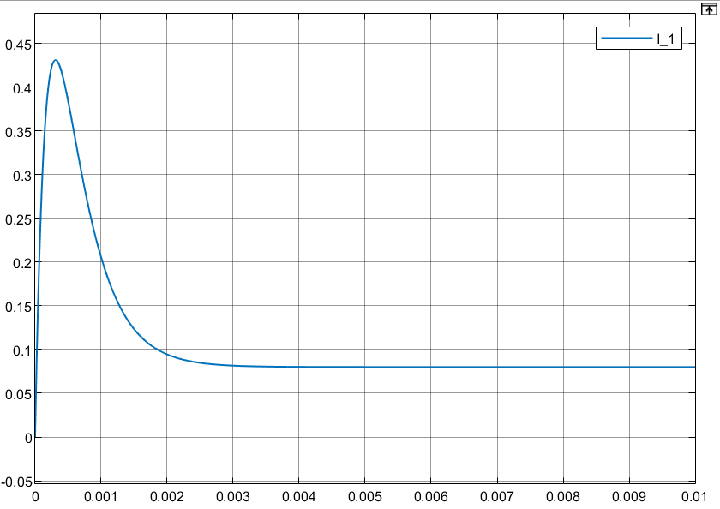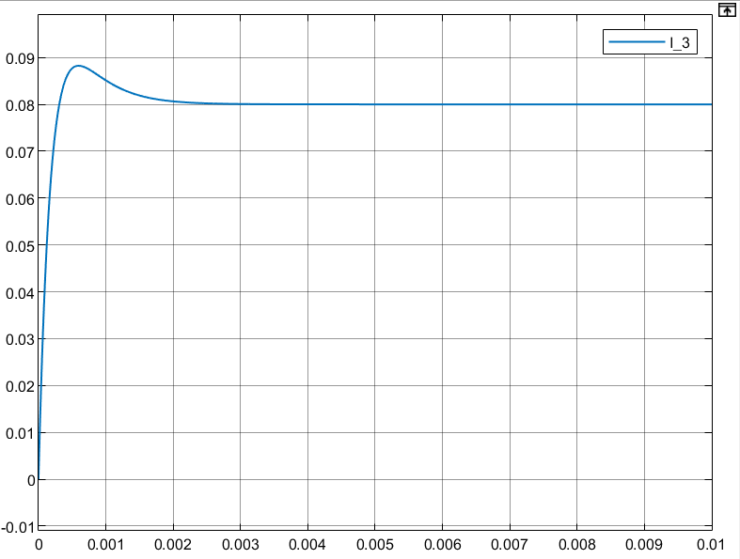

**Figure 3-2.** *simulation of the* ***circuit*** *with* ***zero initial*** *conditions and* ***constant voltage***

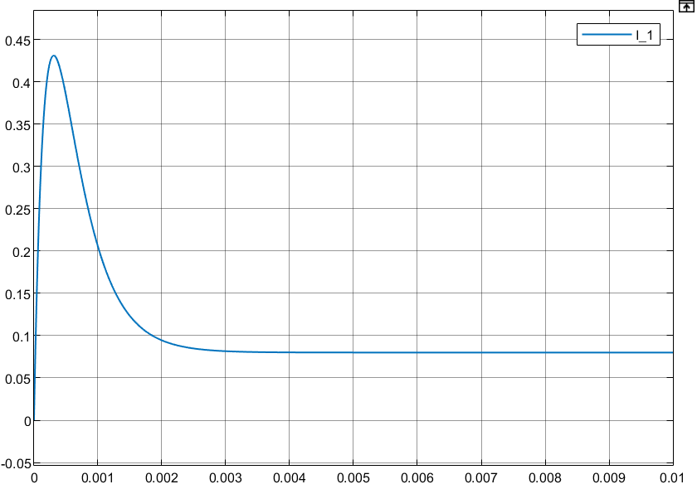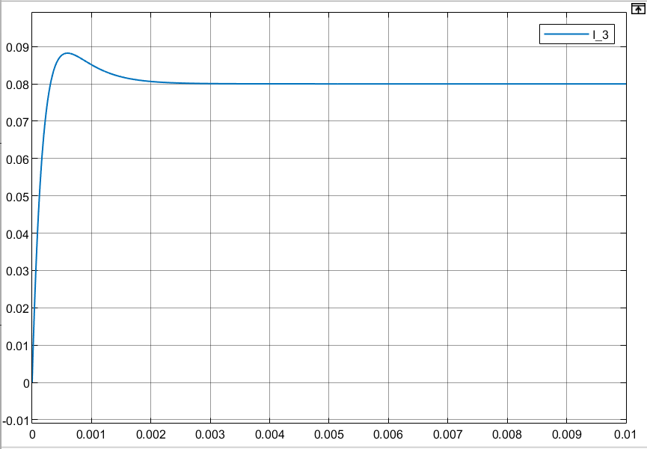

**Figure 3-3.** *simulation of the* ***state-space model*** *with* ***zero initial*** *conditions and* ***constant******voltage***

**Group 2**

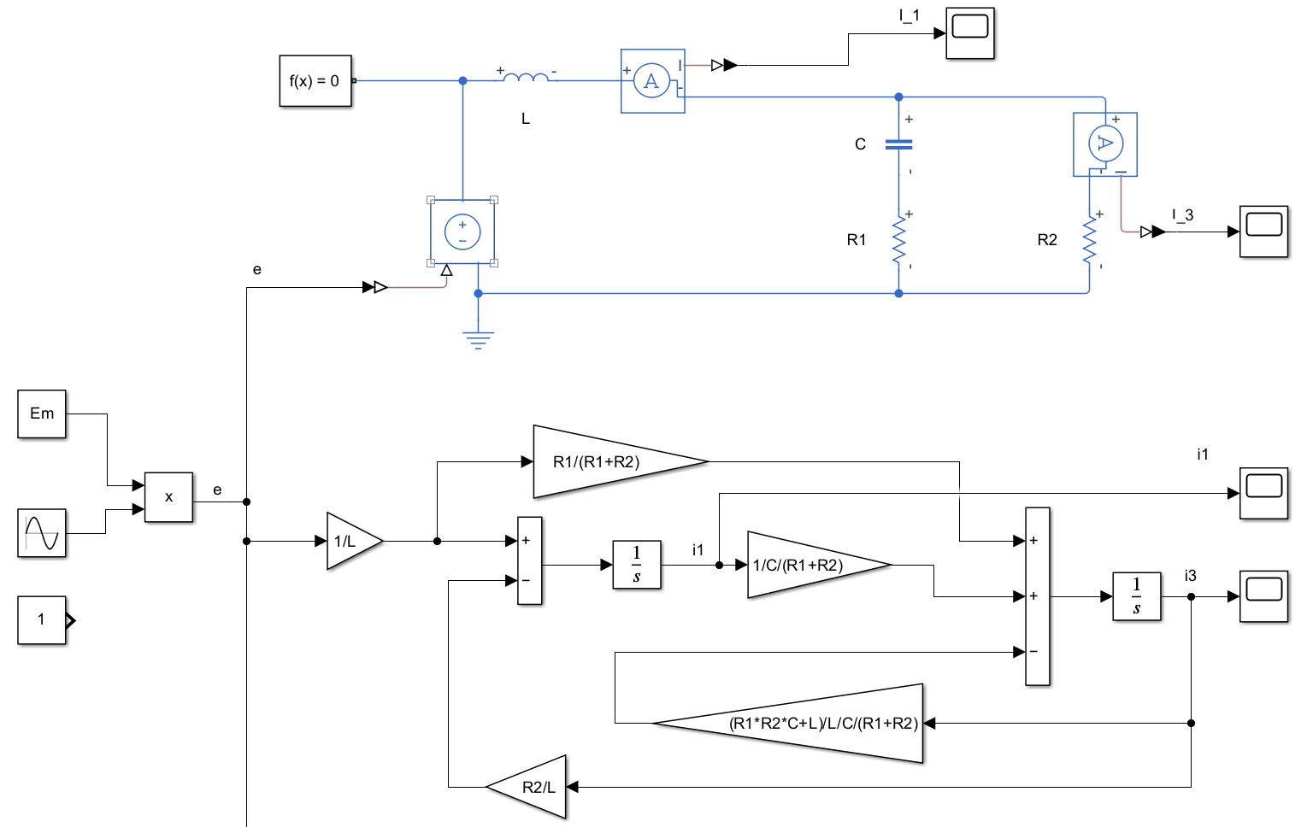

**Figure 3-4.** *simulation with* ***zero initial*** *conditions and* ***sinusoidal input*** *voltage*

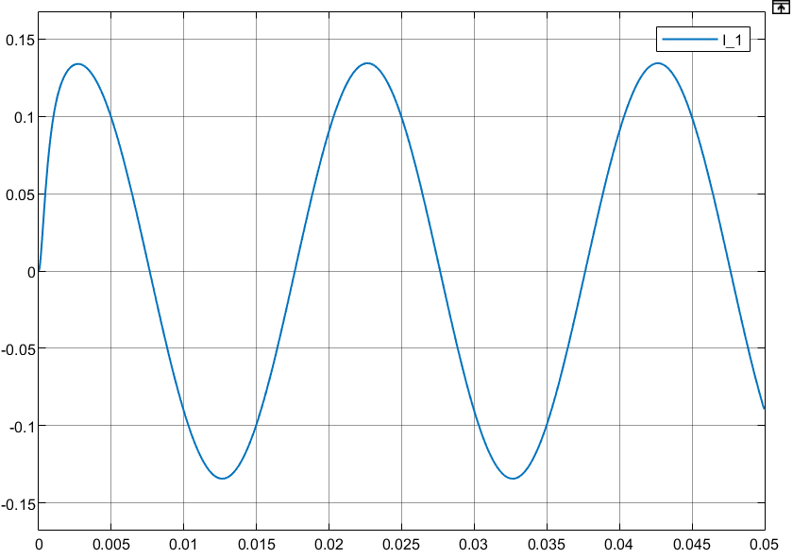 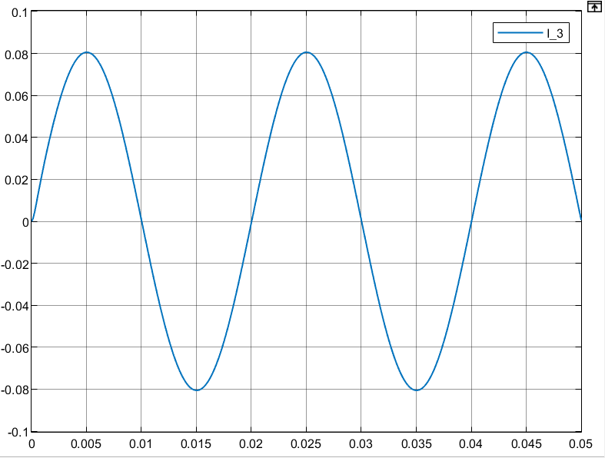

**Figure 3-5.** *simulation of the* ***circuit*** *with* ***zero initial*** *conditions and* ***sinusoidal input*** *voltage*

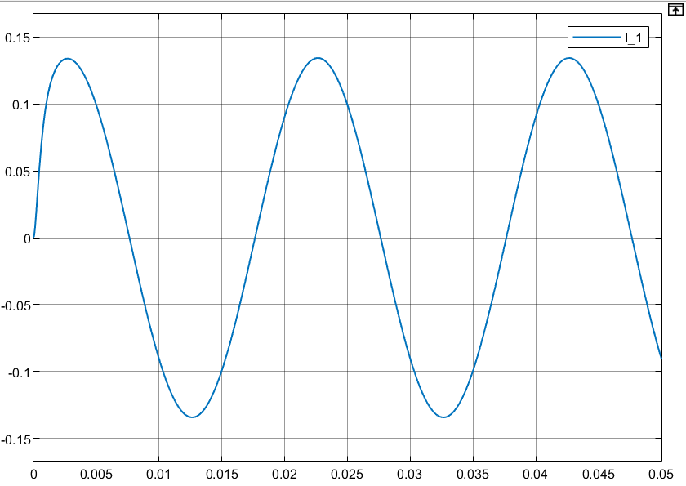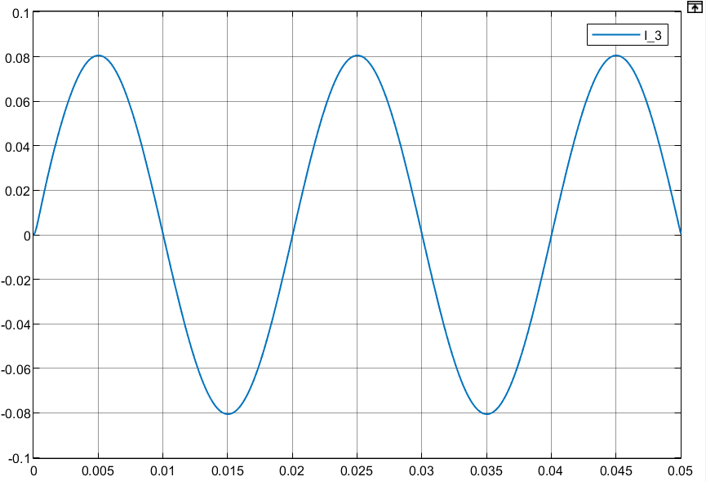

**Figure 3-6.** *simulation of the* ***state-space model*** *with* ***zero initial*** *conditions and* ***sinusoidal input*** *voltage*

**Figure 3.** Simulation results of the circuit and the state-space model.

**Comparison:**

The simulation results of the circuit model and the equation of state model are almost in good agreement.

**6. “Input-output" model.**

Obtain the solution of the system of equations by applying the Laplace transform 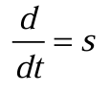 to the state equations:



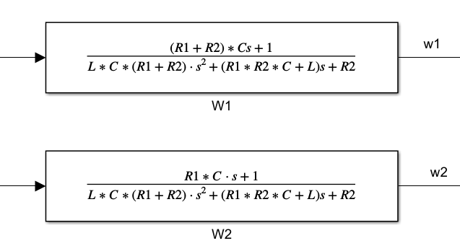

It is necessary to ensure that I1 and I3 are used as status quantities

**7. Simulink simulation of the circuit and the resulting transfer functions using the predetermined input**

**Group 3**

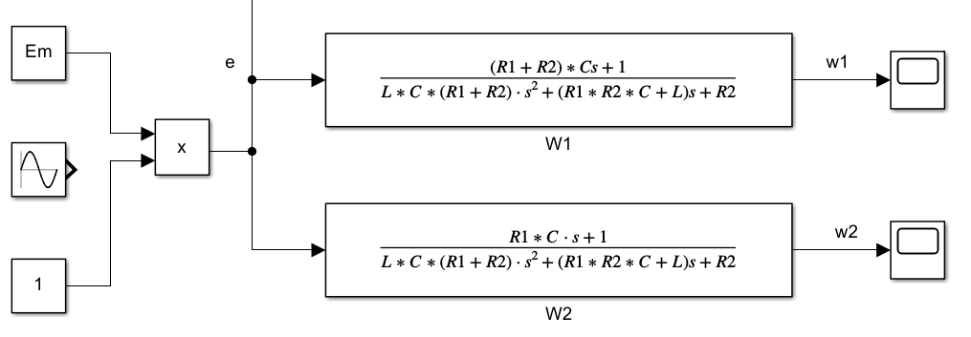

**Figure 4-1.** *simulation of the* ***transfer functions*** *with* ***constant input*** *voltage*

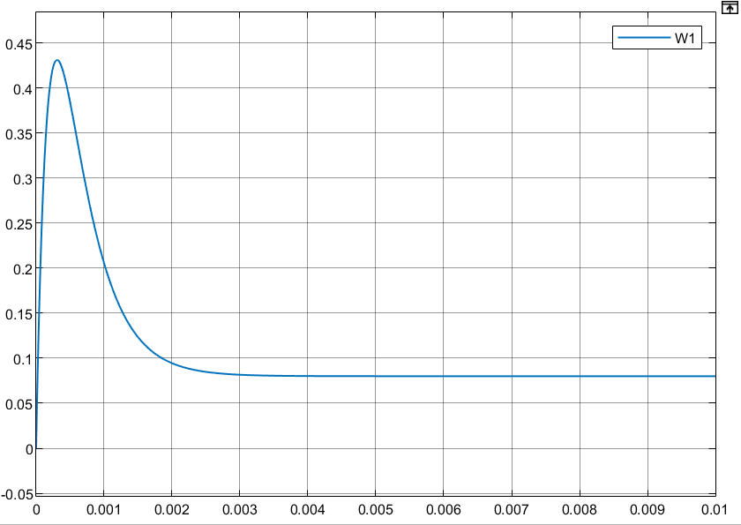 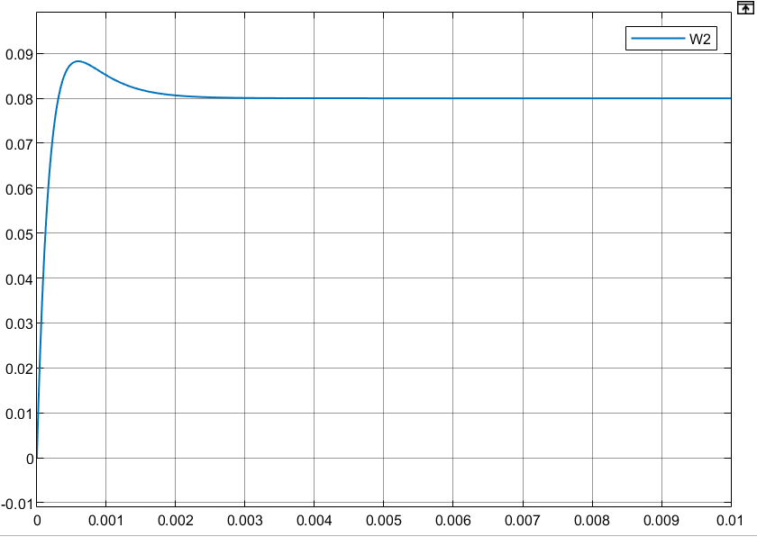

**Figure 4-2.** *simulation of the* ***transfer functions*** *with* ***constant input*** *voltage*

**Group 4**

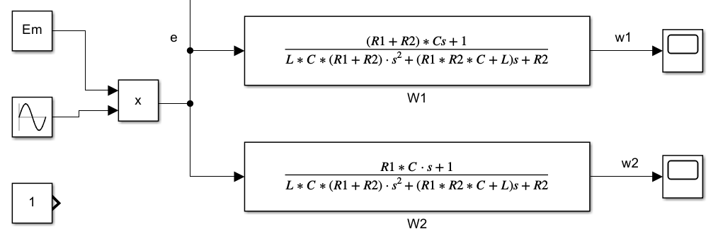

**Figure 4-3.** *simulation of the* ***transfer functions*** *with* ***sinusoidal input*** *voltage*

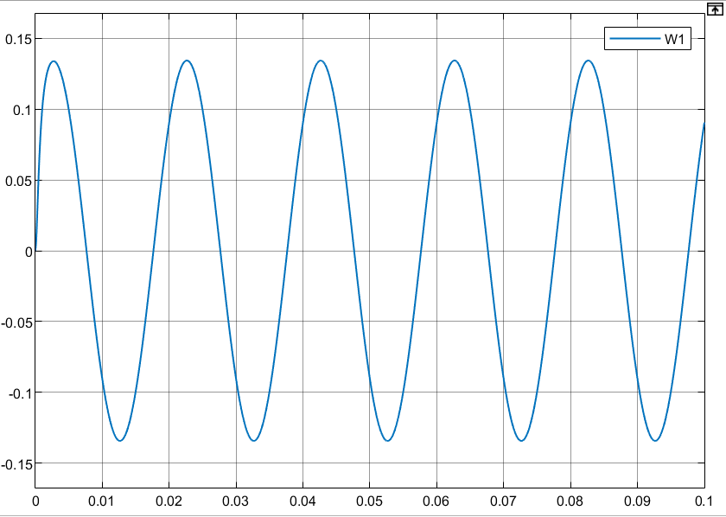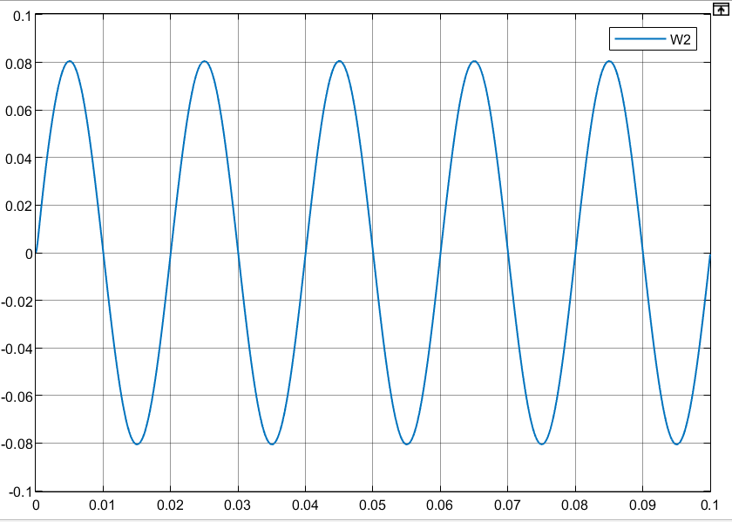

**Figure 4-4.** *simulation of the* ***transfer functions*** *with* ***sinusoidal input*** *voltage*

**Figure 4.** Simulation results of the circuit and the resulting transfer functions.

**Comparison:**

The simulation results of the circuit model and the equation of state model are almost in good agreement

**8. Simulation of the circuit and the state-space model with zero input and non-zero initial conditions.**

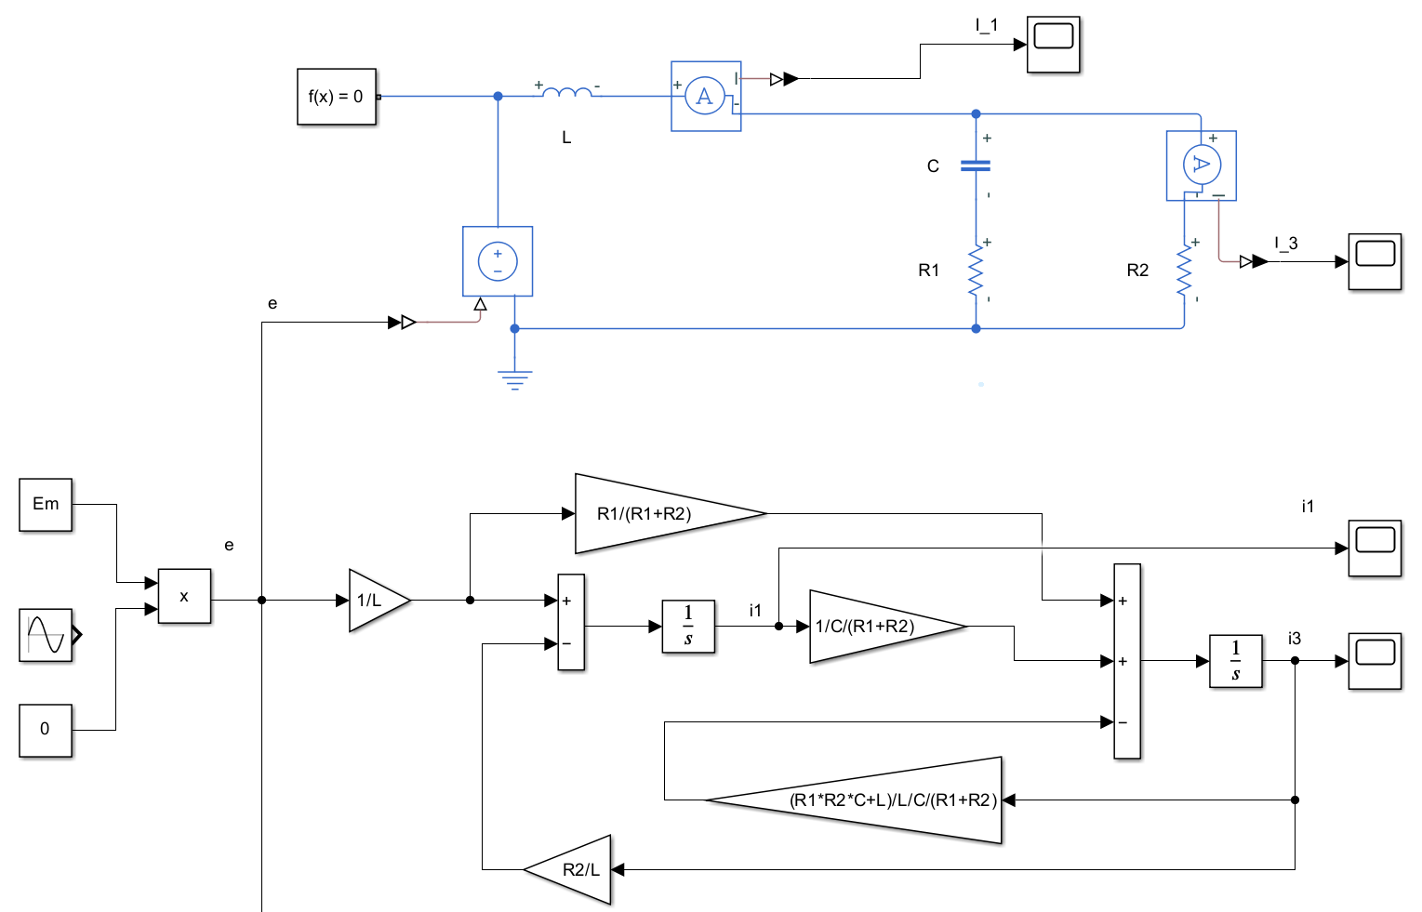

**Figure 5-1.** simulation with zero input and non-zero initial condition

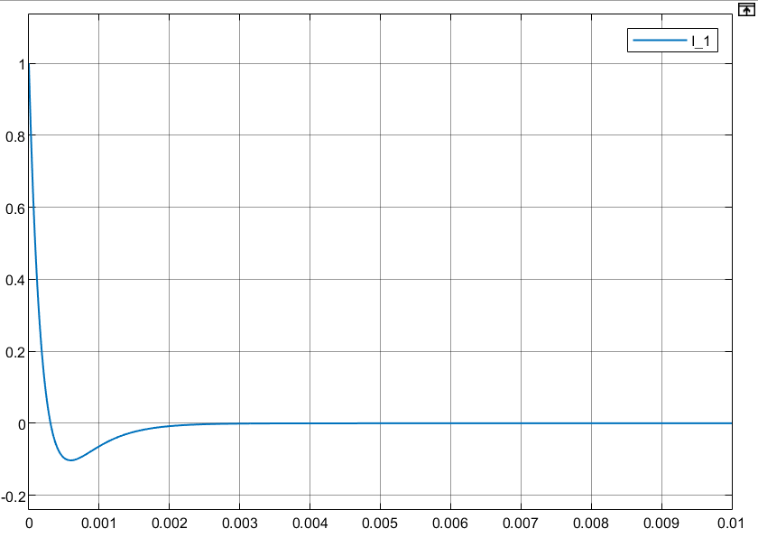 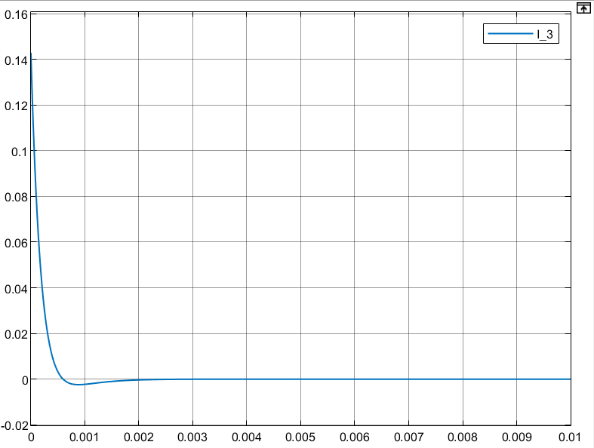

**Figure 5-1.** circuit with zero input and non-zero initial condition

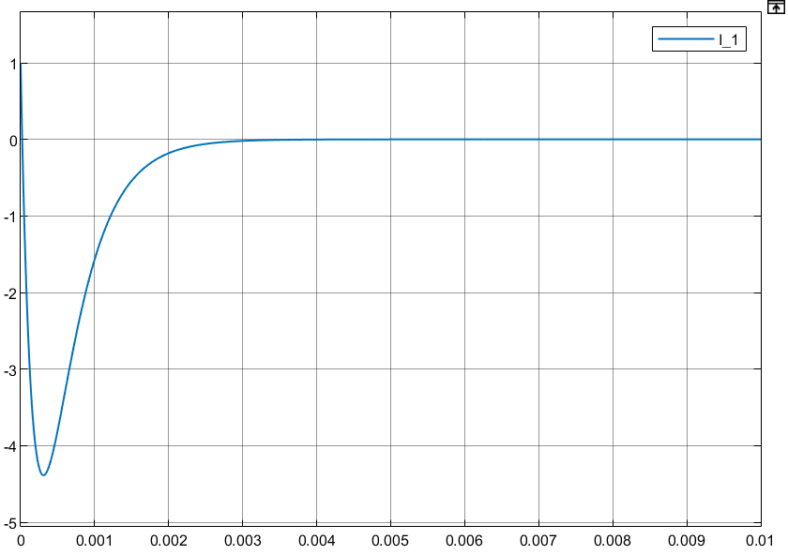 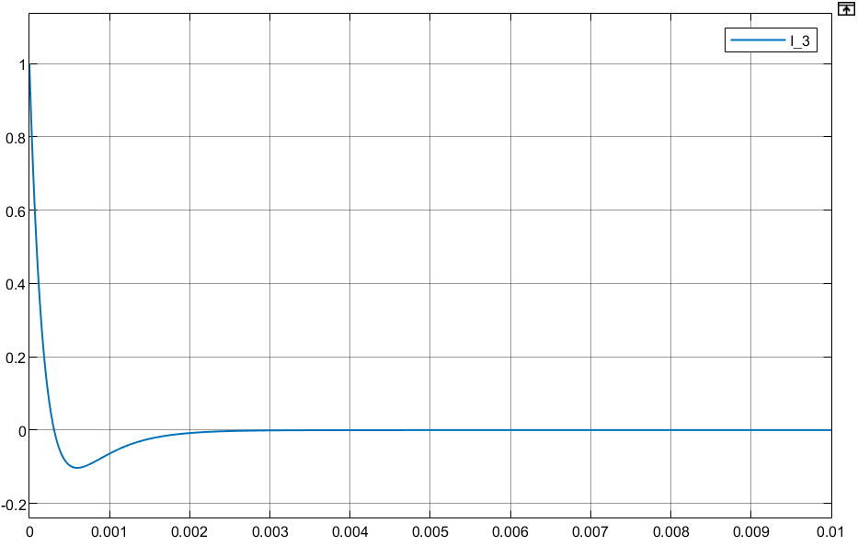

**Figure 5-2.** state-space model with zero input and non-zero initial condition

**Figure 5.** Simulation results of the circuit and the state-space model.

**Comparison:**

The simulation results of I_1 in the Figure 5-2, as the result of state-space model seems to have a extremely fast downward impact. **The transition response of a model utilizing the equation of state takes almost the same time as that of a circuit model**

**Conclusions:**

In this lab, I explored the fundamentals of modeling linear electrical circuits using Simulink. The primary objective was to familiarize myself with the Simulink environment and to understand the basic methods for modeling linear systems. I conducted several simulations to compare the behavior of a circuit model with its corresponding state-space model and transfer function model under different conditions.

**Comparative Analysis:**

* **State-Space Model vs. Transfer Function Model:** I found that both models provided accurate representations of the circuit's behavior under different input conditions. However, the state-space model offers more detailed insights into the internal states of the system, which can be particularly useful for analyzing transient responses and initial conditions.
* **Circuit Model vs. Mathematical Models:** I used the circuit model as the ground truth for validating the mathematical models (state-space and transfer function). The close agreement between the circuit model and the mathematical models confirmed the correctness of the derived equations and the modeling approach.

**Conclusion:**

I successfully demonstrated the effectiveness of using Simulink for modeling and simulating linear electrical circuits. The state-space and transfer function models provided accurate representations of the circuit's behavior, with some minor discrepancies under non-zero initial conditions. These results highlight the importance of choosing the appropriate modeling approach based on the specific requirements of the analysis, such as the need for detailed state information or a simpler input-output relationship.